Reference No EY379776
Preschool Development plan September 2023 – July 2025

Mission Statement:
‘We believe that every child is a capable competent learner, at St. Mary’s Preschool children can thrive on independence, creativity and flourish in our caring environment’
‘We believe that children learn best through participation in play based around their interest’s where they can develop a lifelong love of learning ’
Our Purpose: Every child will enjoy an exciting learning experience whilst developing their independence.
Every child to dream they can achieve what they want with the right disposition
Our Values: We put our children first.
We know every child is unique.
We know children learn through play
We have highly trained and innovative staff that we value.
To develop an outstanding early years practice and continually improve practice.
The strategic priorities
Contents
- Introduction
- The context and development of the plan
- Key priorities
- Development plan

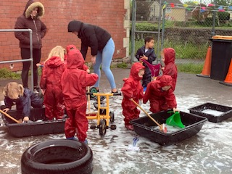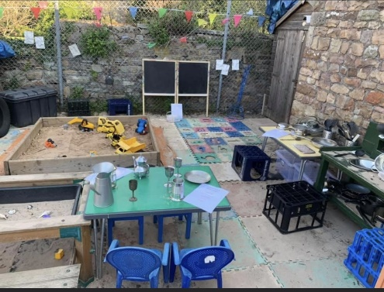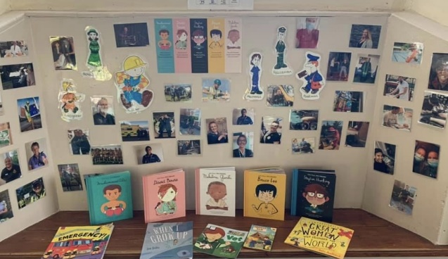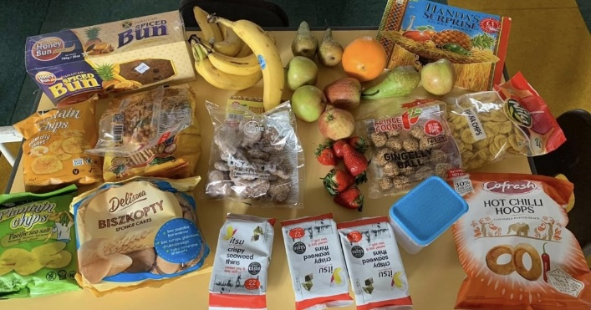

1. Introduction
The purpose of the Preschool School Development Plan is to articulate the key outcomes we are striving towards. It is a tool to help us work together on a shared set of priorities that we feel will make the greatest difference to what our children can achieve.
It addresses priorities that the Pre-school believes are vital to the improvement of the children’s achievement and development at St. Mary’s Pre-School Ltd, Yate.

St Mary’s Pre-School Ltd vision and aims reflect ‘what we want the pre-school to be known for’ and help us translate these high-level principles into operational processes that guide our day-to-day work and decision making.

At St. Mary’s Pre-School Ltd our vision is:

‘We believe that every child is a capable competent learner, at St. Mary’s Preschool children can thrive on independence, creativity and flourish in our caring environment’
‘We believe that children learn best through participation in play based around their interest’s where they can develop a lifelong love of learning ’
This document will show the planned strategies to achieve our objectives, who will be responsible and opportunities to record evidence and progress. As the year, progresses there will be regular opportunities for evaluation of our priorities, to capture and celebrate the progress and to adapt strategies to ensure our outcomes are met.

2. The context and development of the plan
In our April 2018 Ofsted inspection report, Ofsted recommended; To further improve the quality of the early years provision the provider should:

- Continue to build on outdoor improvement plans to provide children with even more learning opportunities, particularly for those children who prefer to learn outdoors.

These recommendations were addressed in our 2020/2021 development plan and are being further enhanced during our developmental plan for this academic year 2021/22.
Some of our aims are short term and some will be longer, for one year so we need to ensure our aims for development have an impact on all children’s learning. Some of our aims will be very different due to the changes of children in our setting and the experiences of their lives which we can share to enhance everyone’s learning and understanding of each other and our differences.

3. Key priorities for 2020-2022
Quality of Education |  | Started | Finished
To promote creativity and Inclusivity through Yoga and music and movement sessions | To Physically enhances children’s flexibility, strength, coordination, and body awareness. In addition, to improve their concentration and sense of calmness, relaxation, and anxiety, to help children self-regulate. | Re start Oct 21 | On going
Develop the outdoor learning area to ensure it provides a haven for children to learn and grow | To use framework to provide outdoor activities which targets for next steps of children’s learning. | April 2021
Develop / Refresh all staff understanding of child devleopment | To ensure all staff have updated / refreshed their knowledge regarding child development, development matters and EYFS reform training | May 21 | Aug 21
Develop parent interaction bags-  Healthy eating bag, Dentist bag and fine motor skills box. | To use in setting and for children to take home, to promote parent interactions  To evidence the impact and receive parent and child’s voice. | June 2021 | Dec 21
Develop inclusion, promoting equality and celebrating our uniqueness – Book library focusing on Inclusion and celebrating BEM | To use in Setting and for parents to take home  Working with a third party offering families book to borrow at home that encourage celebrating uniqueness and promoting different ethnicities  All books suitable for 2 – 5 year olds | Sep 21
Promoting and developing big dreamers and achieveres | To talk about different individuals with different ethnicities and what they have achieved, to open up children’s understanding of what we can do to help and support each other and make the best of ourselves. | Sep 21
Re -start travelling ted home bag | To extend and enable more children to be involved. | Sep 21
Introducing the 3 I’s and staff understanding and evaluating daily practice. | Staff to understand the 3 I’s and to understand the impact on children’s learning and evaluate daily. | Sep 2019 - | Reviewing constantly
Children to go to shop and purchase ingredients for cooking activites | Help children develop the understanding of money, purchasing items and where they come from .. as well as the cooking – start to finish activities | Feb 2020 | Stopped due to covid
Natural resources and curiosity approach | Children able to explore natural resources for sensory development and critical thinking. | July 2020 | Ongoing
Outdoor natural resources and removal of plastic toys | Replenish natural resources to enhance children’s learning, curiosity and critical thinking along with building up knowledge of nature and the impact plastic has on the environment | Re start after covid pandemic is significantly reduced

Behaviour and Attitudes |  |  |  | Started |  | Finished
To promote and encourage parents to attend stay and play sessions for parents |  | Develop parents’ involvement in the setting of their children’s learning and promote positive learning experiences and how to interact in developing home learning . |  | Re started July 2021
All staff understand how children learn and how we promote independence, resilience and understand development matters |  | Staff to know when children need to support but staff do not do it for them.  Encouraging independence training modules and staff meetings for staff to develop their understanding |  | All staff completed EYFS reforms Staff to complete other modules on Vle
Personal Development |  |  | Started |  | Finished
All staff to understand how to use FAmly | Staff training on Family August 21 ready to use in Sep 21 |  | Aug 21 |  | Oct 21
All staff to become responsible for their own learning and developing their own understanding | Staff to complete a range of learning modules and update themselves regularly.  Staff to take on a particular interest and develop it within the setting |  | Ongoing |  | On going  All staff currently doing DOE  2 engaged in further development
All staff to read the information provided by Esther regarding Ethnicity, BEM, culture and celebrating different cultures | Staff to read the information provided by Esther on how best to respond to children’s questions , how to better promote inclusion and books and resources that promote a wider racial inclusion in their stories. |  | July 2021 |  | Dec 2021
All staff understanding which children require support. | Staff aware of when children are playing alone and when to interact - staff meetings and sharing staff knowledge, training modules. Staff to read SEN children’s support plans so they can all interact with SEN children appropriately and to meet the individual child’s needs |  | July 21 |  | Ongoing

Leadership and Management |  | Started | Finished
To increase individual staff support and training | To work regularly every week with each member of staff , asking if they want any further support, checking on their planning and how they assess their children | Sep 21 | On going
To encourage staff well being and build up team resilience | To give staff time to talk about how they are feeling and offer staff support when required  Encourage staff to support each other | Sep 21 | On going
To increase the quality of staff observations and setting next steps | To observe staff and to allow staff to observe senior staff whilst they teach and carry out observations | Oct 23
4. Development plan
Quality of education
Aim | Action | People | Timescale/start | Resources | Monitoring and evaluation
To support quiet children – SM – build up confidence in speaking | All staff to complete Kent training on Selective mutism and staff to read purchased books –  Share
 |  |  |  |  | Restart Autumn 2021
4. Development plan
Behaviour and Attitudes
Aim | Action | People | Timescale/start | Resources | Monitoring and evaluation

4. Development plan
Personal Development | Action |  | People | Timescale/start | Resources | Monitoring and evaluation
All staff to become responsible for their own learning and developing their own understanding | 1. All staff have access to VLe and encouraged to look at the modules and update their knowledge, Manager to offer time during working hours to complete some modules when possible |  | All staff |  |  | All staff currently completing Doe update training 2023  HOLLIE completing PDO and Flo to start Sep 23  Sarah starting level 5 Jan 23.

4. Development plan
Leadership and Management
Aim | Action | People | Timescale/start | Resources | Monitoring and evaluation
To increase individual staff support and training | 1. Actively encourage all staff to attend all training and staff meetings.  Plan prearranged time to meet one to one with each staff member | Rachel | Sep 21 | During supervsiions  Observations  Training and development given | On going

DEVELOPMENT LOG 2020-2022

3. Key priorities for 2020-2022
Quality of Education |  | Started | Finished
To promote creativity and Inclusivity through Yoga and music and movement sessions | To Physically enhances children’s flexibility, strength, coordination, and body awareness. In addition, to improve their concentration and sense of calmness, relaxation, and anxiety, to help children self-regulate. | Re start Oct 21 | On going
Develop the outdoor learning area to ensure it provides a haven for children to learn and grow | To use framework to provide outdoor activities which targets for next steps of children’s learning. | April 2021
Develop / Refresh all staff understanding of child devleopment | To ensure all staff have updated / refreshed their knowledge regarding child development, development matters and EYFS reform training | May 21 | Aug 21
Develop parent interaction bags-  Healthy eating bag, Dentist bag and fine motor skills box. | To use in setting and for children to take home, to promote parent interactions  To evidence the impact and receive parent and child’s voice. | June 2021 | Dec 21
Develop inclusion, promoting equality and celebrating our uniqueness – Book library focusing on Inclusion and celebrating BEM | To use in Setting and for parents to take home  Working with a third party offering families book to borrow at home that encourage celebrating uniqueness and promoting different ethnicities  All books suitable for 2 – 5 year olds | Sep 21
Promoting and developing big dreamers and achieveres | To talk about different individuals with different ethnicities and what they have achieved, to open up children’s understanding of what we can do to help and support each other and make the best of ourselves. | Sep 21
Re -start travelling ted home bag | To extend and enable more children to be involved. | Sep 21
Introducing the 3 I’s and staff understanding and evaluating daily practice. | Staff to understand the 3 I’s and to understand the impact on children’s learning and evaluate daily. | Sep 2019 - | Reviewing constantly
Children to go to shop and purchase ingredients for cooking activites | Help children develop the understanding of money, purchasing items and where they come from .. as well as the cooking – start to finish activities | Feb 2020 | Stopped due to covid
Natural resources and curiosity approach | Children able to explore natural resources for sensory development and critical thinking. | July 2020 | Ongoing
Outdoor natural resources and removal of plastic toys | Replenish natural resources to enhance children’s learning, curiosity and critical thinking along with building up knowledge of nature and the impact plastic has on the environment | Re start after covid pandemic is significantly reduced

Behaviour and Attitudes |  |  |  | Started |  | Finished
To promote and encourage parents to attend stay and play sessions for parents |  | Develop parents’ involvement in the setting of their children’s learning and promote positive learning experiences and how to interact in developing home learning . |  | Re started July 2021
All staff understand how children learn and how we promote independence, resilience and understand development matters |  | Staff to know when children need to support but staff do not do it for them.  Encouraging independence training modules and staff meetings for staff to develop their understanding |  | All staff completed EYFS reforms Staff to complete other modules on Vle
Personal Development |  |  | Started |  | Finished
All staff to understand how to use FAmly | Staff training on Family August 21 ready to use in Sep 21 |  | Aug 21 |  | Oct 21
All staff to become responsible for their own learning and developing their own understanding | Staff to complete a range of learning modules and update themselves regularly.  Staff to take on a particular interest and develop it within the setting |  | Ongoing |  | On going  All staff currently doing DOE  2 engaged in further development
All staff to read the information provided by Esther regarding Ethnicity, BEM, culture and celebrating different cultures | Staff to read the information provided by Esther on how best to respond to children’s questions , how to better promote inclusion and books and resources that promote a wider racial inclusion in their stories. |  | July 2021 |  | Dec 2021
All staff understanding which children require support. | Staff aware of when children are playing alone and when to interact - staff meetings and sharing staff knowledge, training modules. Staff to read SEN children’s support plans so they can all interact with SEN children appropriately and to meet the individual child’s needs |  | July 21 |  | Ongoing

Leadership and Management |  | Started | Finished
To increase individual staff support and training | To work regularly every week with each member of staff , asking if they want any further support, checking on their planning and how they assess their children | Sep 21 | On going
To encourage staff well being and build up team resilience | To give staff time to talk about how they are feeling and offer staff support when required  Encourage staff to support each other | Sep 21 | On going
To offer Hollie more time to develop her leader ship skills | To show Hollie how to complete grant forms, how to complete cohort tracking and to use the Family app | Sep 21 | Hollie currently completing EDP 2023
4. Development plan
Quality of education
Aim | Action | People | Timescale/start | Resources | Monitoring and evaluation
To promote creativity and Inclusivity through Yoga and music and movement sessions | 1. Staff to understand Yoga and basic movements  2. Staff to run yoga in large group time  3. Staff to introduce small group Yoga sessions  4. Staff Rota to promote Yoga in sessions  5. Staff to become familiar with Yoga cards | Whole team | Start Autumn term 2020-2021 | Yoga Cards  Yoga music  CD Player  Use Yoga notes | Large yoga group to be revised again in small groups at least once a week
Develop the outdoor learning area to ensure it provides a haven for children to learn and grow | 1. Staff to develop their knowledge and on forest school  4. Outdoor staff training and forest school training  5. Removal of plastic  6. introduction of more natural resources  7. New outdoor equipment sand/mud kitchen r | Whole team | Re-Start Autumn term 2021 | Regular visits to find natural resources | Plastic re introduced during covid due to the ease of cleaning
All staff understand how to extend children’s learning and how we promote independence | 1. Staff to understand why we promote independence  2. Staff to understand why it’s important to encourage children to do as much for themselves as they can  3. Staff understand not just to do things for children without being encouraged to be independent first. | All team | Autumn Term  2020- 2021 | Inhouse training on promoting independence | Regular update and regular training for all staff – this will always be ongoing
Children to make their own playdough and develop area | 1. Children to look at cause and effect  2. Be able to follow instructions  3. Discuss the benefits of children taking charge of their own learning  4. Promote independence  5. Children to support each other  Children to use natural resources | Whole team | Autumn Term  2020 - 2021 | Flour  Salt  Bowls  Instruction photographs  Low level Wooden unit  Wooden spoons  Storage unit | Restart Autumn 2021
Natural resources and curiosity approach | 1. To introduce more natural resources  2. Look at how the children access resources  3. Plan of the resources required  4. All staff aware of curiosity approach | Whole team | Autumn Term  2020 - 2021 | Collect old items from charity shops to cause curiosity  Purchase book about curiosity  Inhouse training  Outside training | Restart Autumn 2021
Develop inclusion, promoting equality and celebrating our uniqueness – Book library focusing on Inclusion and celebrating BEM | - Purchase new books  - Introduce book lending library scheme for families | Rachel and Esther – also put Esther in touch with local authority | Sep 21- July 22 | Wide range of inhouse books  Esther also has her own library already prepared.
Promoting and developing big dreamers and achievers | 1. Introduce big Dreamers books  2. Plan of resources to suit a wide range of different occupations | Rachel and whole team | July 21 | Dreamers books, all about me books  Different occupation resources
4. Development plan
Behaviour and Attitudes
Aim | Action | People | Timescale/start | Resources | Monitoring and evaluation
To promote the importance of stay and play sessions for parents | 1. Encourage parents to participate and understand the importance of play  2. Send out stay and play letters, phone prospect parents for stay and play  3. Invite parents in who may benefit from watching their children interactions with adults at preschool | RM  HE  SB | July 21 |  | All parents came to stay and play in July 21  All bar one in July 22  All in July 2023
All staff understand how children learn and how we promote independence, resilience and understand development matters | 1. Staff meeting  2. Staff completed EYFS development matters reform training | Whole team | May – Sep 21 | In house training  Outside training  Staff meetings  VLE training modules and reading through the documents provided by manager

4. Development plan
Personal Development | Action |  | People | Timescale/start | Resources | Monitoring and evaluation
All staff to understand how to use FAmly | 1. All staff activated on to Family and a pretend child to practise on  2. All staff to attend Famly Training |  | All staff | June 21  August 21
All staff to become responsible for their own learning and developing their own understanding | 1. All staff have access to VLe and encouraged to look at the modules and update their knowledge, Manager to offer time during working hours to complete some modules when possible |  | All staff |  |  | All staff currently completing Doe update training.
All staff to read the information provided by Esther regarding Ethnicity, BEM, culture and celebrating different cultures | 1. Information was shared with the whole team and the team were given a range of resources and signposted to further information |  | All staff | July 21

4. Development plan
Leadership and Management
Aim | Action | People | Timescale/start | Resources | Monitoring and evaluation
To increase individual staff support and training | 1. Actively encourage all staff to attend all training and staff meetings.  Plan prearranged time to meet one to one with each staff member | Rachel | Sep 21 | During supervsiions  Observations  Training and development given | On going
To encourage staff well being and build up team resilience | Plan and arrange one to one time more regularly with each staff member, ideally once a week to fortnightly | Rachel | Sep 21 | Informal conversations  Chats  Supervisions/observations | On going
To offer Hollie more time to develop her leader ship skills | Plan and arrange time for Hollie to have time away from the children to develop her management skills once a fortnight . | Rachel | October 21 |  | Unachievable during 22/23 due to the amount of high needs children and theh amount of enhanced ratio / 1:1 we needed to give out children

